**WEEK – 1**

**Module 1: DESIGN PATTERN AND PRINCIPLES**

**Exercise 1: Implementing the Singleton Pattern**

**Code:**

class Logger

{

private static Logger instance;

private Logger()

{

System.out.println("Logger in");

}

public static Logger get()

{

if(instance == null)

{

instance = new Logger();

}

return instance;

}

public void logging(String info)

{

System.out.println(info);

}

}

class Main

{

public static void main (String[] args) {

Logger logger1 = Logger.get();

logger1.logging("Application started");

Logger logger2 = Logger.get();

logger2.logging("Same application");

if(logger1 == logger2)

{

System.out.println("Only one instance so Singleton pattern");

}

else

{

System.out.println("Multiple so no Singleton pattern");

}

}

}

**OUTPUT:**

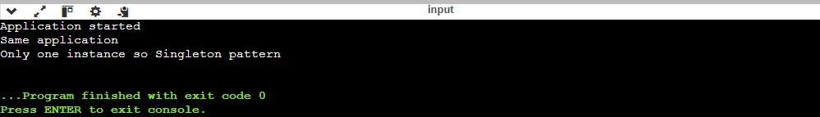

**Exercise 2: Implementing the Factory Method Pattern**

**CODE:**

interface File {

void doctype();

}

class WordDocument implements File {

public void doctype() {

System.out.println("Word Document");

}

}

class PdfDocument implements File {

public void doctype() {

System.out.println("PDF Document");

}

}

class ExcelDocument implements File {

public void doctype() {

System.out.println("Excel Document");

}

}

abstract class DocumentFactory {

public abstract File createDocument();

}

class WordDocumentFactory extends DocumentFactory {

public File createDocument() {

return new WordDocument();

}

}

class PdfDocumentFactory extends DocumentFactory {

public File createDocument() {

return new PdfDocument();

}

}

class ExcelDocumentFactory extends DocumentFactory {

public File createDocument() {

return new ExcelDocument();

}

}

public class Main {

public static void main(String[] args) {

DocumentFactory wordFactory = new WordDocumentFactory();

File word = wordFactory.createDocument();

word.doctype();

DocumentFactory pdfFactory = new PdfDocumentFactory();

File pdf = pdfFactory.createDocument();

pdf.doctype();

DocumentFactory excelFactory = new ExcelDocumentFactory();

File excel = excelFactory.createDocument();

excel.doctype();

}

}

**OUTPUT:**

